Angel Funding/ Venture Capitalist Funding Opportunity for Early Bud Entrepreneurs
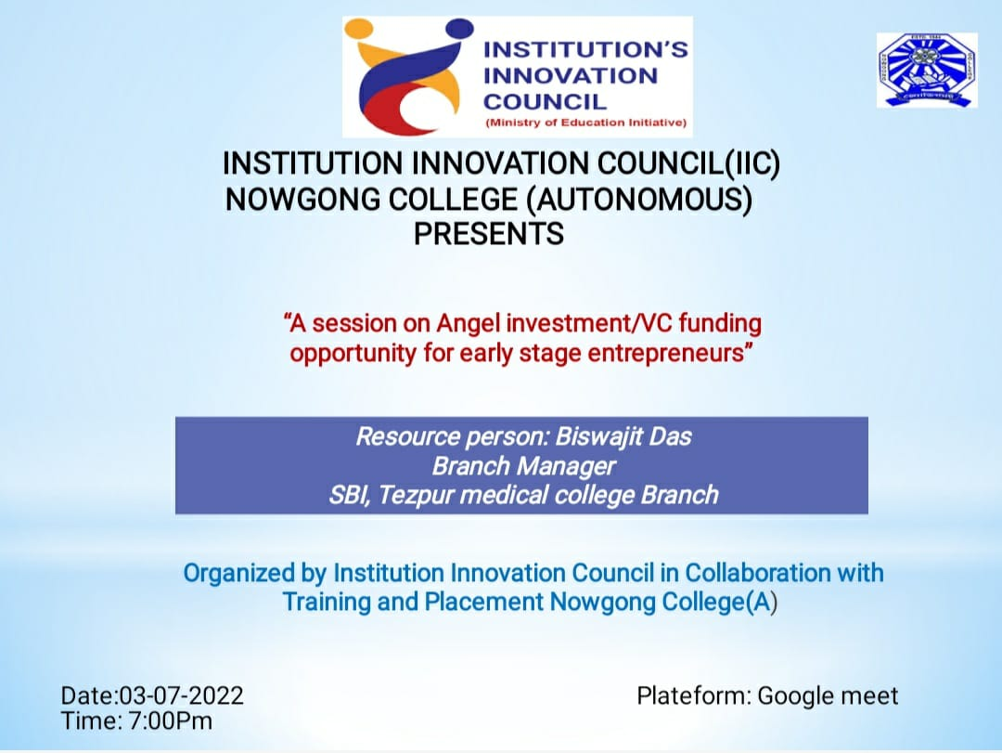

The seminar on Angel Funding/Venture Capitalist Funding Opportunities for Early-Bud Entrepreneurs provided valuable insights into securing early-stage investments. Experts from the startup ecosystem, including prominent venture capitalists and angel investors, discussed key funding strategies, the importance of innovative business models, and effective pitching techniques. Entrepreneurs learned how to attract investors by highlighting scalability, market potential, and sustainable revenue streams. The seminar addressed common challenges faced during fundraising, such as valuation concerns and investor expectations, and emphasized the role of mentorship in refining business ideas. Real-life case studies showcased successful startups that benefited from early funding, inspiring attendees to explore funding options proactively. The session concluded with a networking opportunity, enabling entrepreneurs to connect with investors and peers. Overall, the seminar equipped aspiring business leaders with the knowledge and tools needed to navigate the complex funding landscape and transform their innovative ideas into thriving enterprises.


